FocusMate App

- Problem and Logic Breakdown

Problem: Digital distractions cause extreme burnout to students and remote workers, hence low productivity and poor management.

Solution/logic: A minimalist Pomodoro timer app tailored for study sessions. It includes a basic countdown timer and a simple daily focus score log at the end of each session.

CHAPTER ONE

- Environmental Setup and Installation

- Downloading the Android Studio

Visit https://developer.android.com/studio and click Download for Windows.

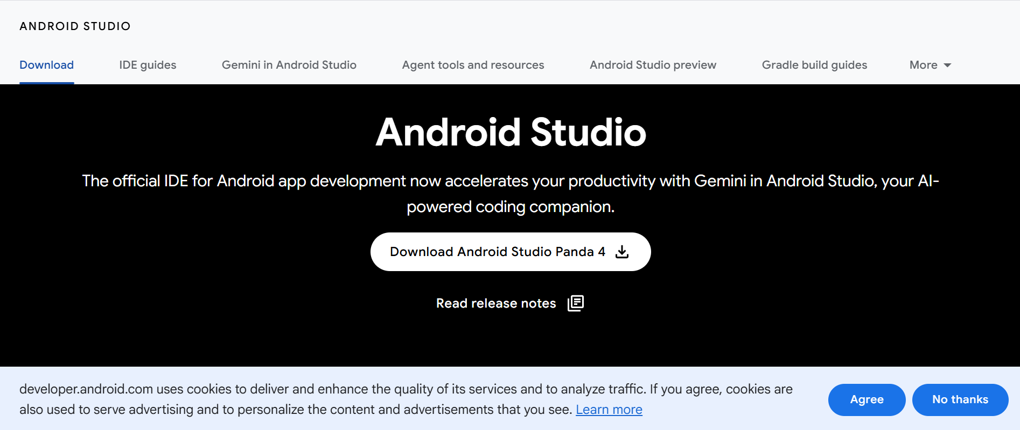

- Running the Installer

Open the file and click next through all the screens. Select an Android virtual Device for testing before completing the installation procedure.

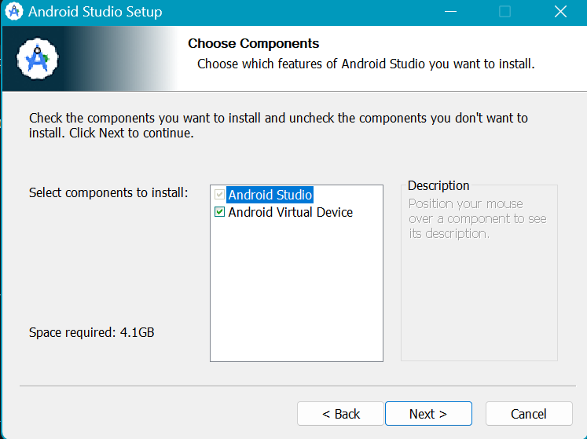

- Completing the Initial Set Up Wizard

Ensure the installation of the SDK is completed.

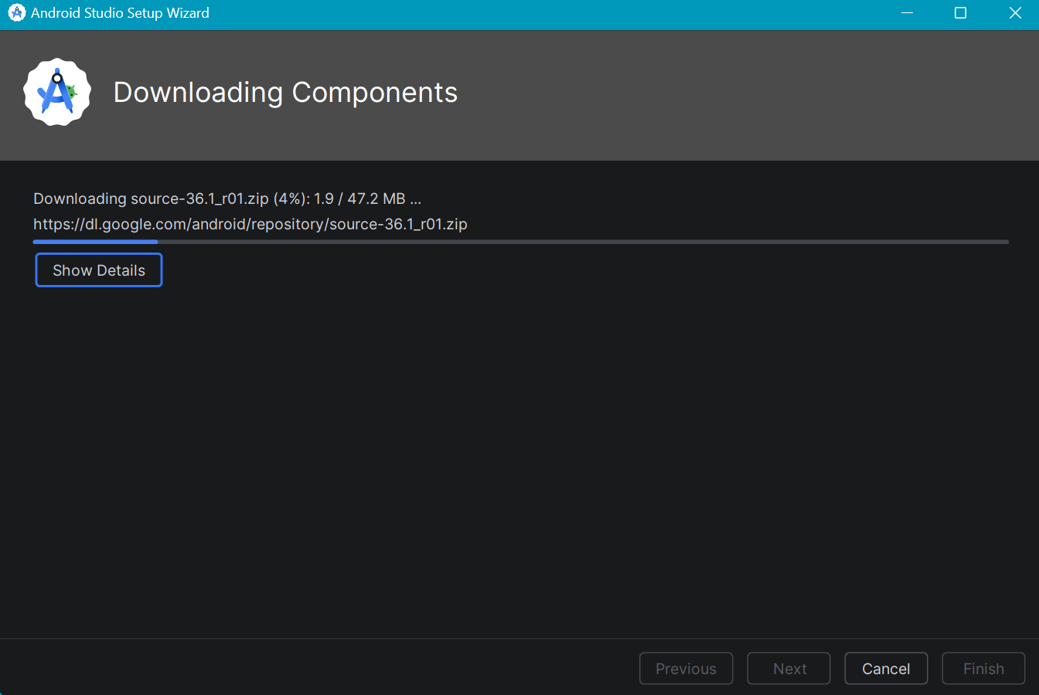

- Creating the Project structure

Click New Project.
Select Empty Views Activity

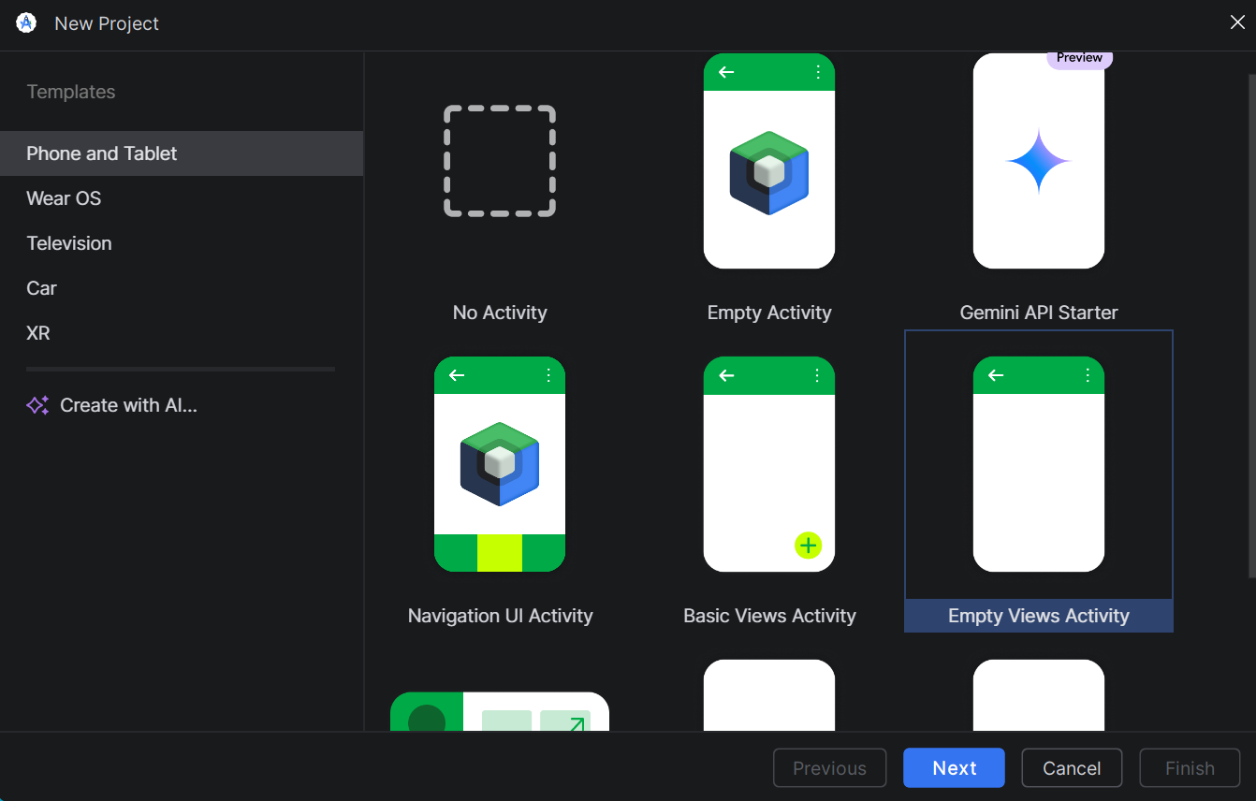
Name the application FocusMate.
Set the language, and leave the Minimum SDK at the default (usually API 24). Click Finish.
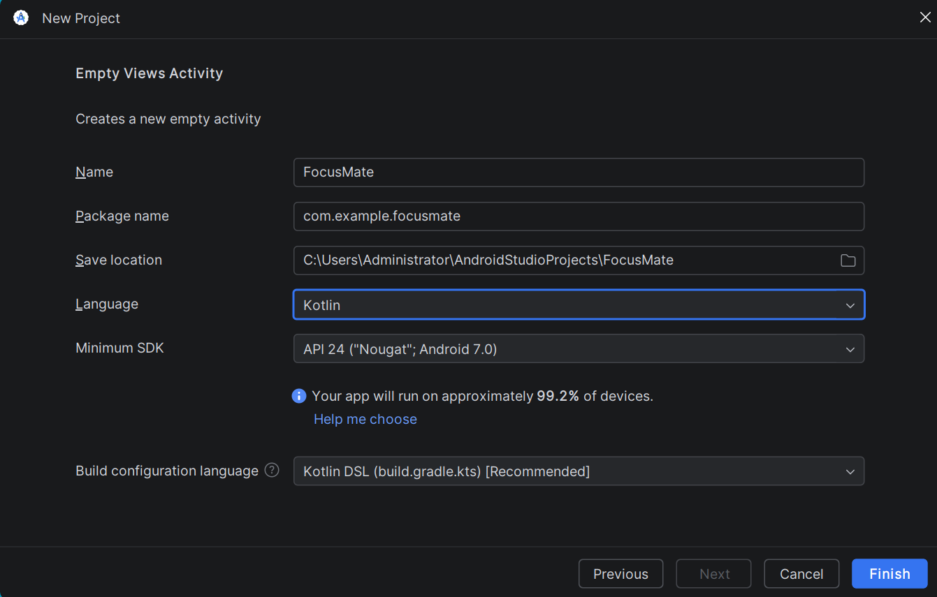

- PROJECT BEGINS

- Download the virtual device manager

For the FocusMate App, I decided to go with Google Pixel 8a, 33API for better visualisation on a standard device.

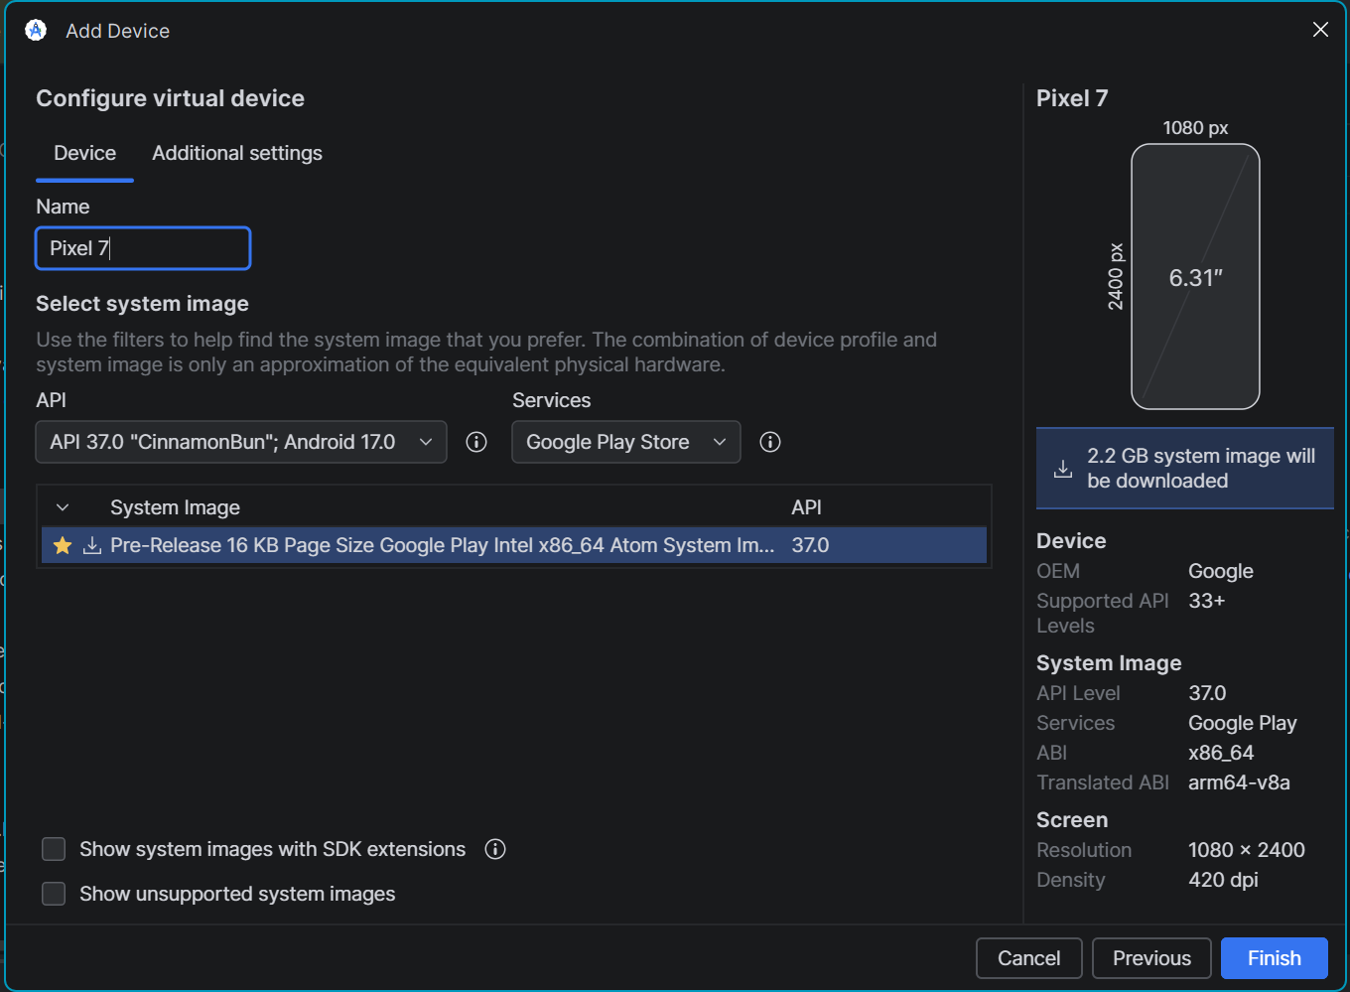

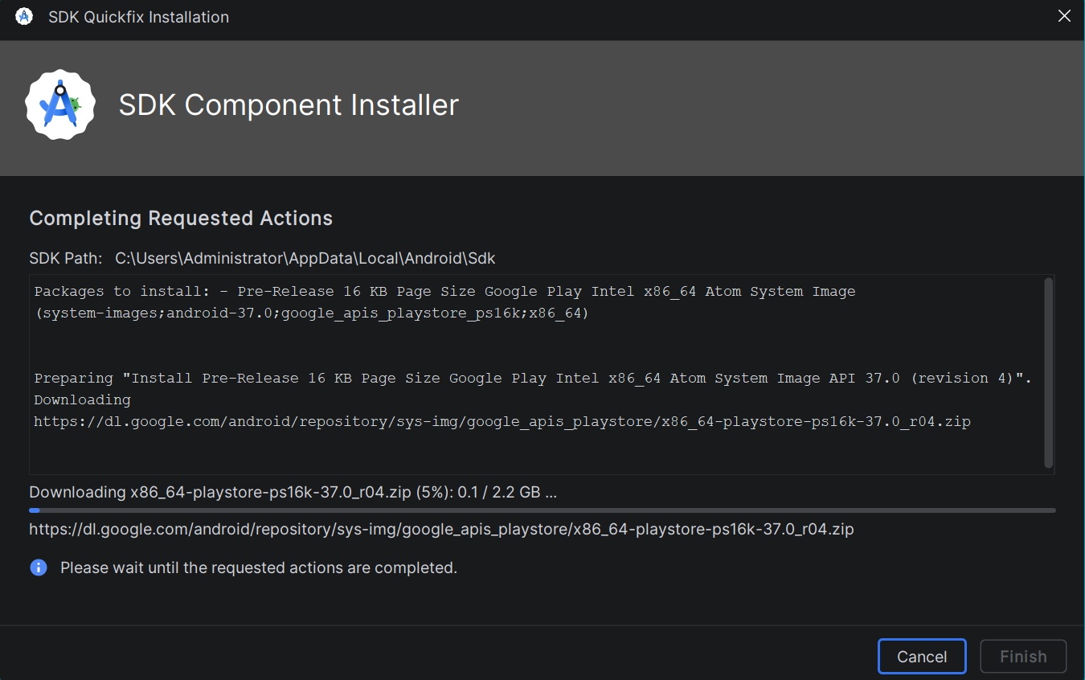

- Test the Virtual device and the first Hello World app.

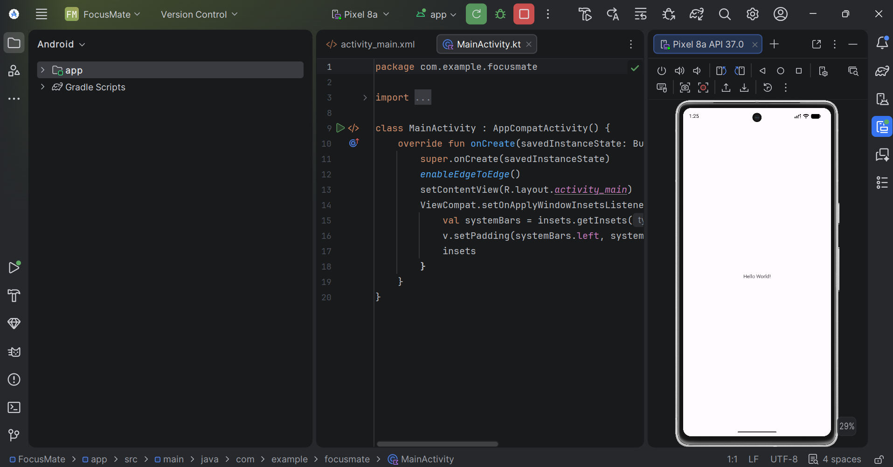

Figure: Successful deployment of Hello world

CHAPTER TWO

1. UI/UX Wireframing and Layout Design

a) User Interface (UI) Architecture.

Using XML code, describe the structure of the code.
In the FocusMate folder, click the downward arrow, then this sequence:
AppSrcMainresLayoutactivity_main.xml
In the open middle screen, use the shortcut: Alt + Shift + Left arrow

Modify the code:

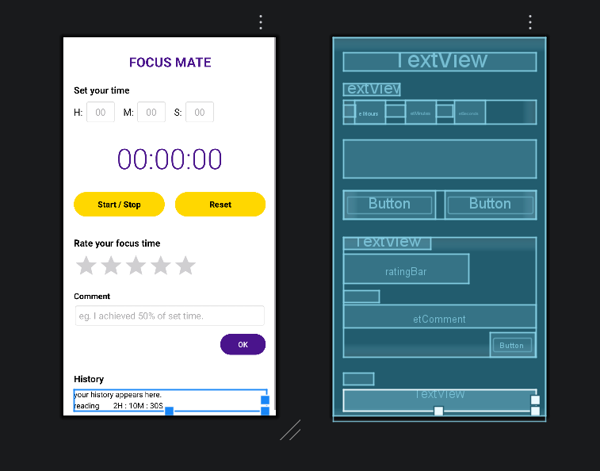
Figure above: Modified XML code for UI appearance and a wireframe.

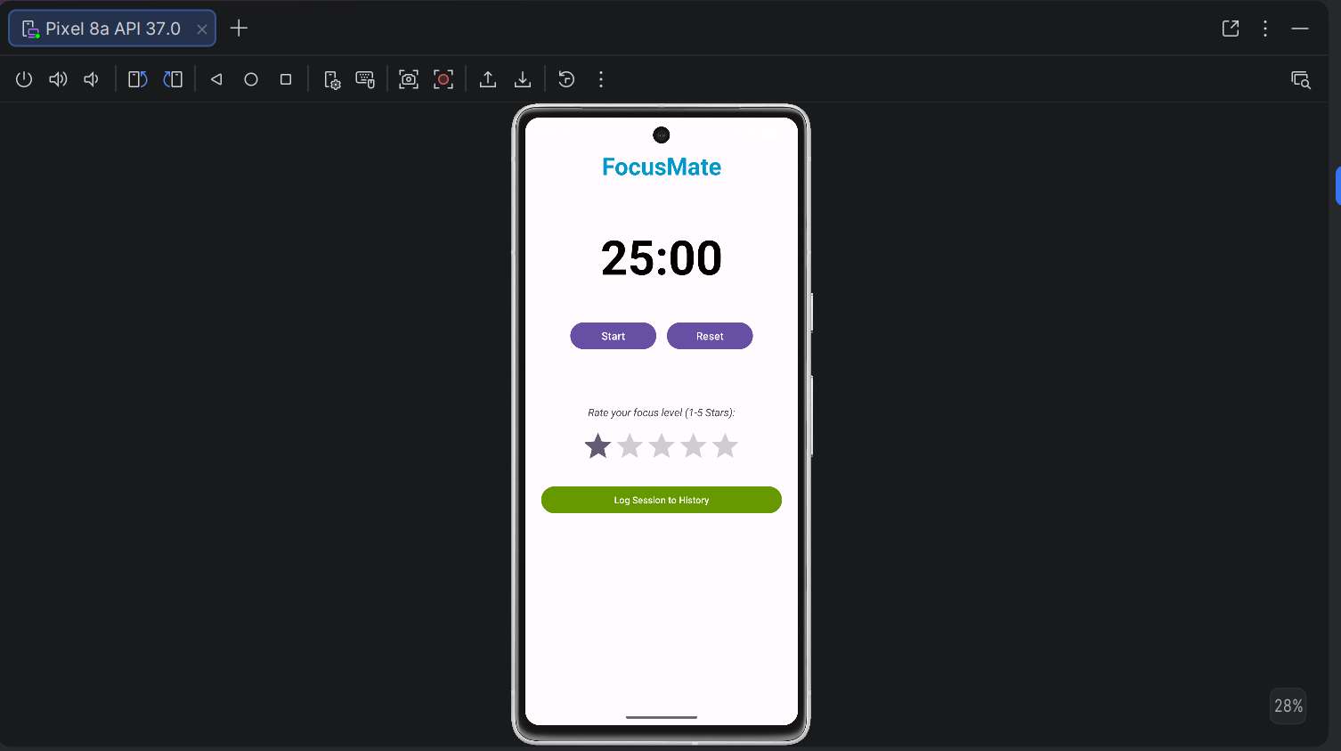
Figure: FocusMate UI successfully compiled and deployed on the virtual device.

